12. CHILDREN'S COURT CLINIC

12.1 Statutory basis and functions of the Clinic
12.2 Referral to the Clinic
12.2.1 Referral from Family Division for a report
12.2.2 Referral from Criminal Division for a report
12.2.3 Terms of reference for Family Division assessments by the Clinic
12.2.4 Terms of reference for Criminal Division assessments by the Clinic
12.3 Operation of the Clinic
12.3.1 Ethos
12.3.2 Qualifications and experience of clinicians
12.3.3 Clinical assessments
12.3.4 Statistics
12.4 Children’s Court Clinic reports
12.4.1 The competing principles
12.4.2 Distribution of and access to Family Division reports
12.4.3 Distribution of and access to Criminal Division reports
12.4.4 Confidentiality of Children’s Court Clinic reports

12.1 Statutory basis and functions of the Clinic

The Children’s Court Clinic is an independent body within the Victorian Government Department of Justice & Community Safety. The Clinic has provided a unique and invaluable service to the Children's Court of Victoria for over 80 years since its foundation within the Law Department in 1942. Its statutory basis is derived from s.37(1) of the Children and Young Persons Act 1989 (Vic) [No.56/1989] ('the CYPA') and it is continued in operation by s.546(1) of the Children, Youth and Families Act 2005 (Vic) [No.96/2005] (‘the CYFA’).

The functions of the Clinic are defined in s.546(2) of the CYFA as follows:
- to make clinical assessments of children;
- to submit reports to courts and other bodies;
- to provide clinical services to children and their families.

Located in the Melbourne Children's Court building, the Clinic is a state-wide service which supplies clinical psychological, neuropsychological and psychiatric opinions for the judicial officers of the Court. Until 2017/2018 the Clinic also provided a small clinical treatment service for children and/or family members during an adjournment period of a case in either the Family Division or the Criminal Division of the Children’s Court.

The Clinic is independent of all of the parties in every case and hence is a bastion of independent, professional psychological/psychiatric expertise within a highly specialised court jurisdiction. Until 2001 it was the only such Clinic in Australia.

Until her retirement in October 2018 the Clinic was under the strong and inspired leadership of Dr Patricia Brown, a clinical and forensic psychologist, for 53 years. Dr Sophie Reeves then led the team as the Clinic Director until her resignation in March 2021. Dr Lisa Forrester and Dr Paula Verity were appointed as Acting Directors until 4 August 2021 when Dr Forrester was appointed as Director. Dr Forrester – who commenced working directly with the Clinic as a sessional clinician in 2018 before moving to a permanent part-time, senior clinical and forensic psychologist role in March 2019 – holds a Doctorate of Psychology (Clinical) and a Bachelor of Behavioural Science (Hons) and has considerable professional experience across a range of adult and youth clinical, forensic, prison and community settings.

It is the writer’s strong belief that the Clinic’s work is well respected by the Courts and the legal fraternity. In 1997 the Australian Law Reform Commission recommended in its Report #84 “Seen and Heard: Priority for Children in the legal process” that the Victorian Children’s Court Clinic be the prototype for other such clinics to be established for the Children’s Courts in other Australian States & Territories. This ultimately led to the establishment in 2001 of the New South Wales Children’s Court Clinic. In 2007 Dr Brown received the Australian Psychological Society Award for “Distinguished Contributions to Forensic Psychology”. In 2009 the Children’s Court Clinic received the Children’s Court Award.

12.2 Referral to the Clinic

It is important to note that a Children’s Court Clinic involvement with a family cannot be initiated without an order of the Court and can usually only occur while a case is on-going in the Court. The Clinic – assiduously and correctly – sees its role as working only for judicial officers and not for any party in proceedings before the Court. Thus it has no separate jurisdiction to be involved with a child or family before an application is filed with the Court and generally has no separate jurisdiction to be involved with a child or family once the Court has concluded the hearing of the case in the absence of a specific request by a judicial officer.

Clinic involvement is initiated by the Court making a referral requesting the Clinic-
- in Family Division cases: to prepare an additional report pursuant to s.560(b) or another type of report pursuant to s.546(2)(b); or
- in Criminal Division cases: to prepare a pre-sentence report pursuant to ss.571 & 572(b) or another type of report pursuant to s.546(2)(b); or
- in cases in either Division: to provide clinical services to children and their families pursuant to s.546(2)(c) of the CYFA.

Subject to the legislative pre-conditions detailed below, the Court may make a referral to the Children's Court Clinic in any appropriate case, either of its own motion or upon application by any party. The nature of the request made by the Court may be highly specific or unspecific, but in all cases the Clinic provides a comprehensive clinical picture of the child and his or her family to assist the relevant judicial officer in decision-making or provides the requested clinical services.

12.2.1 Referral from Family Division for a report
Referrals from the Family Division typically involve requests for a clinical opinion on:
- family dynamics, including parent-child attachment and parenting capacity;
- parental mental health, children’s mental health and developmental needs and parent/child cognitive capacity; and
- risk of harm to children within a family environment where they have been exposed to family violence, sexual abuse and/or another form of maltreatment.
Recommendations in relation to a child’s contact with parents, residence and support services that are in a child’s best interests also form a typical part of Clinic requests. Further, the Clinic is receiving increased numbers of referrals from both Divisions for neuropsychological assessments.

The Court’s power to make these types of referrals requesting an assessment of child and family functioning and the provision of associated recommendations is effected by ordering an “additional report” pursuant to s.560(b) of the CYFA. The Court has power to make such a referral in any proceeding in which a disposition report is required under s.557(1) if of the opinion that such a report is necessary to enable it to determine the proceeding.

Section 560 CYFA had sometimes been read – in conjunction with s.557(1)(a) – as limited to ‘post-proof’ Clinic reports. However, in DE (a pseudonym) v DFFH [2021] VSC 691 at [32] Ginnane J rejected DE’s submission (which DFFH ultimately had not supported) that the CCV cannot order an additional report without first having made a finding that the child was in need of protection:
“[T]he proper construction of s.557(1)(d) is that the Children’s Court may order a disposition report at any time in the proceeding. An interpretation permitting the Children’s Court to order a Children’s Court Clinic report to help determine whether a child is in need of protection prior to a finding being made under s.274 is consistent with the Act’s principle that the best interests of the child must always be paramount.”
In summarizing his judgment at [39] his Honour concluded that the Children’s Court has power to order an additional report under s.560 at any stage of a proceeding, including when being asked to approve consent orders dismissing a protection application. However as s.560 deals with ‘additional reports’, these must be reports that are filed or provided when a disposition report has previously been ordered or is required under s.557(1). For a detailed report on this case see section 5.24.5 of these Research Materials.

A further type of Family Division report – authorized by s.73A(1) of the Family Violence Protection Act 2008 (Vic) or s.53(1) of the Personal Safety Intervention Orders Act 2010 (Vic) – is an assessment report in respect of a respondent and/or an affected person or protected person who is the subject of an application for an intervention order under one of other of those Acts.

An example of another type of Family Division report is for an assessment of the intellectual functioning and development of a child to enable the determination of whether the child is mature enough to give instructions to a legal representative: see e.g. s.524(2) of the CYFA.

12.2.2 Referral from Criminal Division for a report
The most usual type of referral from the Criminal Division is for a pre-sentence report pursuant to ss.571 & 572(b) of the CYFA. The purpose of a pre-sentence report is to assist in the sentencing of a child who has been found guilty or has pleaded guilty to one or more offences. The only matters which can be set out in pre-sentence reports are detailed in ss.573(1), save that s.573(3) permits a recommendation as to the appropriate sentencing order.

Since 31/10/2014 the Court has power under ss.38P(c) & 38Q(1)(b) of the Crimes (Mental Impairment and Unfitness to be Tried Act) 1997 (Vic) to require a child whose fitness to be tried is in issue to undergo an examination by a registered psychologist or a registered medical practitioner. This is usually through the auspices of the Children’s Court Clinic.

The Court may consider authorising a request – on application by the defence (or both the defence and the prosecution) – for a Clinic assessment to assist in the determination of whether a child is doli capax. However, it is important to note that the ultimate burden of proof of doli capax rests on the prosecution beyond reasonable doubt and the High Court has emphasised that it is not a low standard: see e.g. BDO v The Queen [2023] HCA 16 at [48] applying RP v The Queen [2016] HCA 53; (2016) 259 CLR 641. The writer considers that referral for such an assessment upon an application by the prosecution which is opposed by the defence may pose an unacceptable risk of infringing the accused child’s right to silence.

12.2.3 Terms of reference for Family Division assessments by the Children’s Court Clinic
The following two documents have been used in the Family Division since 2019 to provide terms of reference for-
- a child protection assessment and report; and
- an intervention order assessment and report-
by the Children’s Court Clinic. Electronic versions of these forms can be downloaded from the CCV website.

For each of the documents depicted in this section it is intended-
- that registry staff send to the Clinic completed terms of reference approved and signed by a judicial officer together with any documents identified therein by the judicial officer; and
- that the Clinic make only those enquiries as are identified and authorised by the Court in the terms of reference.

TERMS OF REFERENCE FOR CHILD PROTECTION ASSESSMENTS

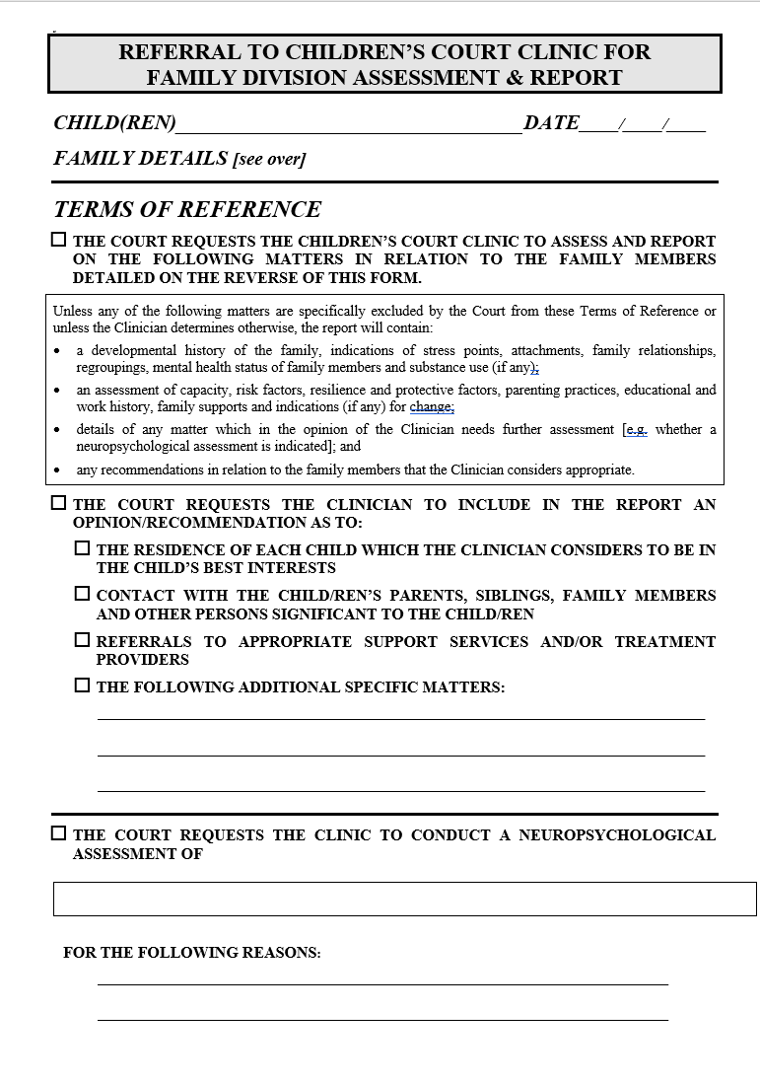

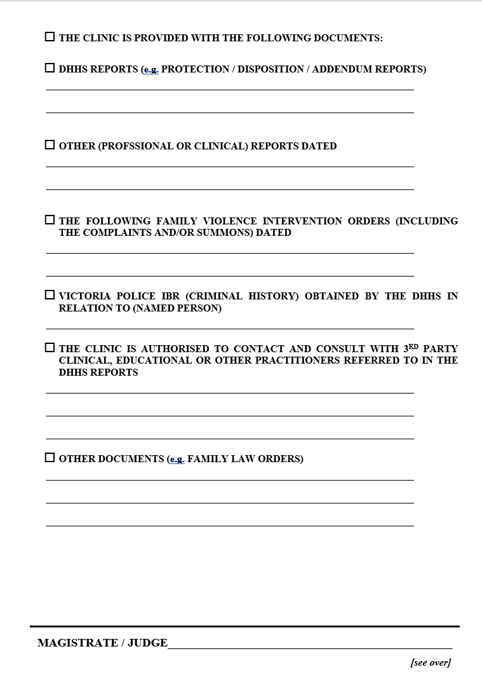 33

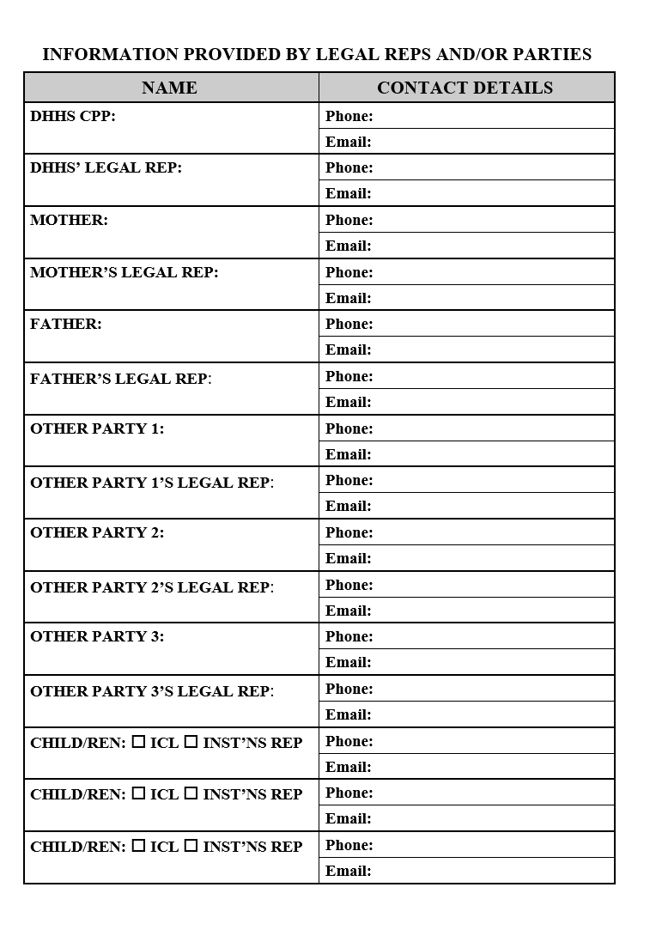

TERMS OF REFERENCE FOR INTERVENTION ORDER ASSESSMENTS
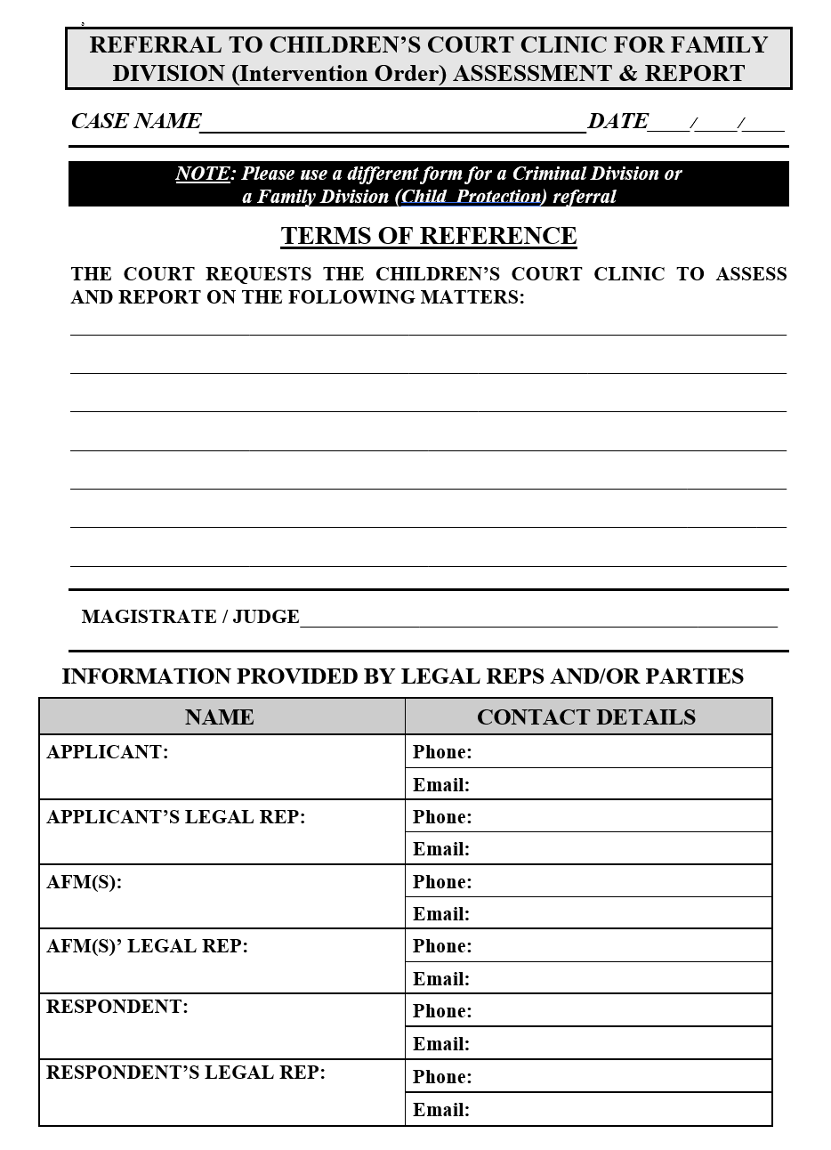

12.2.4 Terms of reference for Criminal Division assessments by the Children’s Court Clinic
The following document has been used since 2019 to provide minutes of proposed terms of reference for a Criminal Division assessment and report by the Children’s Court Clinic. An electronic version of this form can be downloaded from the CCV website. The document was approved by then President Judge Chambers and was endorsed by then Clinic director Dr Sophie Reeves. These terms of reference may also authorise the Clinic, at the direction of the presiding judicial officer, to make enquiries of other agencies or professionals involved with the child.

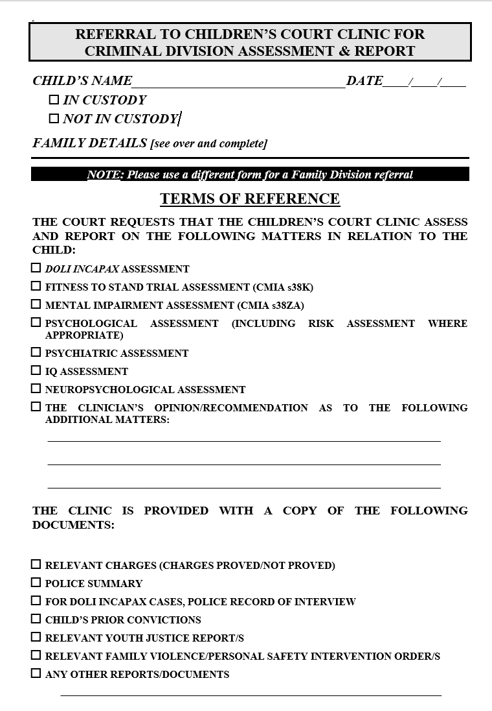
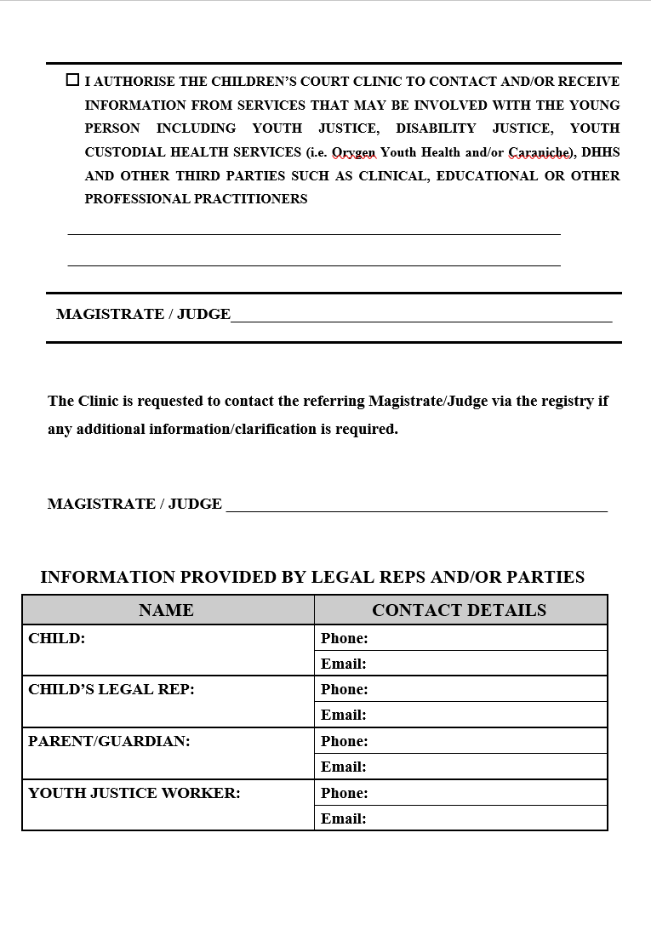

12.3 Operation of the Clinic

12.3.1 Ethos
The ethos of the Clinic is one of professionalism and respect for the persons assessed. The good of the child is the central focus of assessments, but the Clinic is family centred and a systems approach, as well as a developmental perspective, is taken.

12.3.2 Qualifications & experience of clinicians
The Clinic is currently staffed by a number of highly skilled and competent clinicians, assisted by a small administration team.

Many clinicians who work within the Clinic also hold academic and research positions within tertiary institutions, and/or hold clinical positions either within the public mental health sector, or forensic treatment services. All clinicians hold post-graduate training at a Masters level or higher, and have demonstrated their expertise in clinical and/or forensic settings.

The Clinic also works through sessional clinicians engaged by the Director. This allows the Clinic to seek input from specialist clinicians – including all psychiatric assessments – where specific expertise is sought.

12.3.3 Clinical assessments
Clinic assessments involve a comprehensive information gathering process that allows for the specific Terms of Reference to be addressed by the clinician, thereby enabling appropriate recommendations to be made to the Court. Depending on the nature of the case, a substantial amount of time may be required in interviews with family members, carers and relevant support agencies (including Youth Justice and the Department of Families, Fairness and Housing), and psychological tests may also be administered. Interpreters are engaged whenever needed. If further highly specific assessment is needed, for example, neurological assessment, assessment for learning disorders, or where treatment for a mental health/psychological issue is indicated, this will be recommended for consideration by the Court within the report provided. Whilst the Clinic does not initiate or facilitate any such recommendations, where possible it tries to provide specific referral options. As such, any follow-up of the Clinic’s recommendations is the responsibility of the Court (generally by way of conditions on orders), DFFH or the family.

Prior to the COVID-19 pandemic, all referrals to the Children’s Court Clinic were assessed within the Clinic building located within the Children’s Court premises in Melbourne. However, where a young person is in custody, or residing in Secure Welfare, clinicians are able to travel to these facilities to undertake their assessment. From March 2020 onwards, the pandemic has had a large impact on Clinic assessments. There has been a significant reduction in Criminal Division referrals commensurate with a significant drop in charges filed in the Children’s Court during the various ‘lockdown’ periods. In addition, Stage 4 restrictions, which came into effect in late July 2020, resulted in the Clinic solely conducting tele-health assessments for the period during which face-to-face assessments were not permitted. As such, many reports provided to the Court during this period were somewhat modified in the issues that could be addressed. Currently, assessments are undertaken using a combination of telehealth and in-person assessment processes, which allows for the risks to staff and families to be minimized, whilst also allowing for the necessary interviews and observations considered necessary to the assessment process to proceed.

A clinician submitting a report is available for cross-examination at city, metropolitan or country courts when subpoenaed by a party or required to attend by notice given under s.550 of the CYFA by the child, a parent, the Secretary of the Department of Families, Fairness & Housing or the Court. Though the clinician will sometimes attend country courts in person, more often his or her evidence will be by video-conferencing link. In 2013/2014 a notice under s.550 was given to a clinician in 122 cases and in 4 cases a sub-poena was served on a clinician. Cross-examination of the clinician eventuated in 34 of these 126 cases (27% of requests for attendance).

Subject only to the question of relevance to the specific referral received, it is a decision for the individual clinician which persons should be involved in the clinical assessment in any particular instance. The case of NM, DOHS v BS [Children's Court of Victoria, unreported, 21/12/2004] involved applications to extend and to revoke a guardianship to Secretary order in circumstances where the 4 year old child BS was living with long-term carers subject to a permanent care caseplan. A Children's Court Clinic report had been prepared in which the clinician had performed an assessment of the carers which was not favourable to the DOHS' case. Counsel for DOHS strenuously submitted that this report was inadmissible, the court having no jurisdiction to receive it. In ruling that the assessment of the carers performed by the Clinic was both relevant and admissible, Judge Coate held that where the court has ordered a clinic report and the child's current placement is in issue, it is the decision for the particular clinician as to whether or not those carers should form part of the clinical assessment. At p.17 Her Honour said:
"In this case, a professional assessment has been undertaken and is available to assist the court in assessing the actual and potential benefit to the child of that placement. It is crucial, particularly in circumstances where DOHS have made it clear that they do not intend to call [the carers] to give evidence, that all available evidence with respect to them be before the court in these proceedings to allow the court to fulfil its statutory function."

12.3.4 Statistics
NUMBERS OF CHILDREN REFERRED TO THE CLINIC FOR ASSESSMENT
YEAR | CRIMINAL  DIVISION | CHILD  PROTECTION | FAMILY  VIOLENCE | TOTAL | METRO- POLITAN | COUNTRY
1996/1997 | 186 (28%) | 468 (72%) |  | 654
1997/1998 | 212 (26%) | 531 (72%) |  | 743
1998/1999 | 161 (28%) | 458 (74%) |  | 619
1999/2000 | 165 (26%) | 459 (74%) |  | 624
2000/2001 | 176 (28%) | 444 (72%) |  | 620
2001/2002 | 223 (34%) | 427 (66%) |  | 650
2002/2003 | 265 (35%) | 497 (65%) |  | 762
2003/2004 | 222 (25%) | 666 (75%) |  | 888
2004/2005 | 229 (25%) | 686 (74%) | 10 (1%) | 925
2005/2006 | 224 (25%) | 640 (71%) | 29 (3%) | 893
2006/2007 | 303 (30%) | 682 (67%) | 34 (3%) | 1022* | 660 | 362
 | There were 3 “other” referrals in 2006/2007: an assessment of the ability of a 5 year old child to give evidence in a case and 2 special referrals of youths from the Melbourne Magistrates’ Court.
2007/2008 | 346 (32%) | 697 (65%) | 29 (3%) | 1072 | 717 | 355
2008/2009 | 313 (29%) | 712 (65%) | 60 (6%) | 1085 | 686 | 399
YEAR | CRIMINAL  DIVISION | CHILD  PROTECTION | FAMILY  VIOLENCE | TOTAL | METRO- POLITAN | COUNTRY
2009/2010 | 337 (31%) | 725 (66%) | 28 (3%) | 1090 | 683 | 407
2010/2011 | 299 (31%) | 613 (65%) | 39 (4%) | 951 | 608 | 343
2011/2012 | 258 (30%) | 583 (67%) | 31 (3%) | 872 | 540 | 332
2012/2013 | 262 (34%) | 487 (64%) | 18 (2%) | 767 | 475 | 292
2013/2014 | 232 (30%) | 518 (68%) | 16 (2%) | 766 | 493 | 273
2014/2015 | 293 (30%) | 671 (68%) | 23 (2%) | 987 | 601 | 386
2015/2016 | 280 (28%) | 641 (70%) | 19 (2%) | 992 | 627 | 365
2016/2017 | 229 (27%) | 629 (72%) | 6 (1%) | 864 | 490 | 374
2017/2018 | 259 (30%) | 582 (68%) | 14 (2%) | 855 | 522 | 333
2018/2019 | 202 (22%) | 703 (77%) | 9 (1%) | 914 | 507 | 407
2019/2020 | 140 (30%) | 332 (70%) | 2 (0.3%) | 474
2020/2021 | 36 (11%) | 281 (89%) | 4 (0.1%) | 321
 | The significant reduction in the numbers of referrals in 2019/2020 & 2020/2021 is primarily a consequence of the COVID-19 pandemic and its impact on the number of cases initiated in and the throughput of the Children’s Court.

On average approximately 65% to 80% of the referrals to the Clinic involve child protection cases in the Family Division of the Children’s Court. The child protection referrals predominate in the work of the Clinic, these matters usually being more complex and time consuming that the pre-sentence reports which comprise the bulk of the referrals from the Criminal Division.

The referrals shown in the above table relate to individual children. In child protection referrals it is usual for a single report to be prepared for a family whether that family has one child or multiple children (including half-siblings and step-siblings). It follows that the number of reports prepared by the Clinic in child protection referrals is significantly less than the number of children referred. For instance, in 2018/2019 703 children were referred in child protection cases and the Clinic prepared 300 reports.

CLINIC REPORTS PREPARED ACROSS BOTH DIVISIONS
YEAR | TOTAL NUMBER | DESCRIPTION
2018/2019 | 493 | For the Family Division 300 reports were prepared. For the Criminal Division 159 psychological reports were prepared. A total of 34 psychiatric reports were completed for the two divisions.
2019/2020 | 384 | For the Family Division 198 family assessment reports, 39 neuropsychological reports and 12 psychiatric reports were prepared. For the Criminal Division 97 psychological assessment reports, 27 neuropsychological reports and 11 psychiatric reports were prepared.
2020/2021 | 182 | For the Family Division 113 reports were prepared. For the Criminal Division 36 reports were prepared. A further 33 reports were neuropsychological assessments undertaken across both divisions.
2021/2022 | 198 | For the Family Division 134 family assessment reports were prepared for child protection cases. For the Criminal Division 38 psychological or psychiatric reports were prepared. A further 26 reports were neuropsychological assessments undertaken across both divisions.
2022/2023 | 226 | For the Family Division 127 family assessment reports were prepared for child protection cases. For the Criminal Division 36 psychological or psychiatric reports were prepared. A further 63 reports were neuropsychological assessments undertaken across both divisions.

12.4 Children's Court Clinic reports

12.4.1 The competing principles
Under s.546(2)(b) of the CYFA one of the functions of the Clinic is “to submit reports to Courts and other bodies”. Whenever the Clinic provides a report to the Court two competing principles come into play. The principle of “natural justice” requires that all parties to the litigation have a right to a full and fair hearing, a right which ordinarily requires the Court to ensure that all parties are aware of – and are given a proper opportunity to respond to – all evidence to which the Court is privy. On the other hand, there is the principle of “clinician-client confidentiality”, the ethical imperative of the clinician who conducted the assessment to preserve the confidentiality of the information obtained from his or her client in the course of the professional assessment, an imperative necessarily tempered by the fact that the assessment is conducted in the knowledge that the clinician is required to prepare a report for the Court. While the Court understands that a clinician would wish to preserve as much of this confidentiality as possible, the principle of “natural justice” would rarely be satisfied if the Court kept the information in a Clinic report away from some or all of the parties.

12.4.2 Distribution of and access to Family Division reports
If the Family Division of the Court orders a report from the Children’s Court Clinic, s.562(1) of the CYFA requires the Clinic within 21 days and not less than 3 working days before the hearing to forward the report to the proper venue of the Court.

Section 562(2) permits the Clinic, if it is of the opinion that information contained in a Clinic report will be or may be prejudicial to the physical or mental health of a child or a parent of the child, to forward a statement to that effect to the Court with the report.

Section 562(3) of the CYFA tips the balance between “natural justice” and “clinician-client confidentiality” overwhelmingly on the side of “natural justice’ in requiring the Court to release a copy of the report to each of the following-
(a) the child;
(b) the parent(s);
(c) the Secretary;
(d) the legal practitioners representing the child;
(e) the legal practitioners representing the parent(s);
(f) the legal representative of the Secretary or an employee authorized by the Secretary to appear in proceedings before the Family Division;
(g) a party to the proceeding; and
(h) any other person specified by the Court.

The only circumstances in which the Court may refuse to make a full release to each of the above persons are set out in s.562(4). After having regard to the views of the parties and any statement from the Clinic under s.562(2), the Court may-
(a) if satisfied that the release of the report or a particular part to the Secretary may cause significant psychological harm to the child-
- release the report to the Secretary nonetheless;
- refuse to release the report or part report to the Secretary; or
- determine a later time for the release or part thereof to the Secretary;
(b) if satisfied that the release of the report or a particular part to any other person will be prejudicial to the development or mental health of the child, the physical or mental health of the parent or the physical or mental health of that person or any other party-
- release the report to the person nonetheless;
- refuse to release the report or part report to the person; or
- determine a later time for the release or part thereof to the person.

Section 562(5) of the CYFA empowers the Court to impose conditions in respect of the release of a Children’s Court Clinic report. However, it is the writer’s view that s.562(5) does not impose an unfettered power on the Court which would enable it to impose conditions which are contrary to the general release provisions in s.562(3), read in conjunction with s.562(4).

12.4.3 Distribution of and access to Criminal Division reports
If the Criminal Division of the Court orders a pre-sentence report from the Children’s Court Clinic, s.574 of the CYFA requires the Clinic at least 4 working days before the return date no later than 21 days after the report was ordered to file the report with the proper venue of the Court.

Although the Court is now responsible for distributing Family Division Clinic reports, the Clinic remains primarily responsible for distributing its pre-sentence reports. Section 575(2) requires the clinician, within the period referred to in s.574, also to send a copy of a pre-sentence report to-
(a) the child;
(b) the legal practitioners representing the child; and
(c) any other person whom the Court has ordered is to receive a copy.

However, it is clear from ss.575(2) & 575(3) of the CYFA that the clinician is not required to send copies of the report to (a) the child or (c) any other person whom the Court has ordered is to receive a copy if-
- the clinician is of the opinion that information contained in the report may be prejudicial to the physical or mental health of the child; or
- the child notifies the clinician that he or she objects to the forwarding of copies of the report.

If the clinician withholds the report from (a) the child or (c) other person, he or she must inform the appropriate registrar of that fact. The Court may endorse the clinician’s action or may by order direct the appropriate registrar to forward a copy of the report, or a specified part thereof, as soon as possible to the person to whom access had been denied [s.575(4)].

Distribution of and access to any report ordered in the Criminal Division other than a pre-sentence report does not appear to be the subject of any legislative provisions.

12.4.4 Confidentiality of Children’s Court Clinic reports
Subject to any contrary direction by the Court, a person who prepares or receives or otherwise is given access to any Family Division report, or part report, must not, without the consent of the child or parent, disclose any information contained in that report, or part report, to any person not entitled to receive or have access to the report or part. The prohibition in s.552(1) of the CYFA also applies to a copy of such report. Breach of this confidentiality provision is subject to a penalty of 10 penalty units [$1817].

The above confidentiality provisions do not prevent–
- the Secretary or his or her employee or legal representative; or
- an honorary youth justice officer or an honorary parole officer to the extent necessary to exercise his or her powers or perform his or her duties-
from being given or having access to a report to which Part 7.8 of the CYFA applies.

If because of s.575(2) part or all of a pre-sentence report was not sent to the child, s.575(5) prohibits a person who receives a copy - unless otherwise directed by the Court - from disclosing to the child any information contained in the report or part that was not sent to the child. Breach of this confidentiality provision is also subject to a penalty of 10 penalty units.

