12. CHILDREN'S COURT CLINIC

12.1 Statutory basis and functions of the Clinic
12.2 Referral to the Clinic
12.2.1 Referral from Family Division for a report
12.2.2 Referral from Criminal Division for a report
12.2.3 Terms of reference for Family Division assessments by the Clinic
12.2.4 Terms of reference for Criminal Division assessments by the Clinic
12.3 Operation of the Clinic
12.3.1 Ethos
12.3.2 Qualifications and experience of clinicians
12.3.3 Clinical assessments
12.3.4 Statistics
12.3.5 Research role
12.4 Children’s Court Clinic reports
12.4.1 The competing principles
12.4.2 Distribution of and access to Family Division reports
12.4.3 Distribution of and access to Criminal Division reports
12.4.4 Confidentiality of Children’s Court Clinic reports

12.1 Statutory basis and functions of the Clinic

The Children’s Court Clinic is an independent body within the Victorian Government Department of Justice & Community Safety. The Clinic has provided a unique and invaluable service to the Children's Court of Victoria for over 80 years since its foundation within the Law Department in 1942. Its statutory basis is derived from s.37(1) of the Children and Young Persons Act 1989 (Vic) [No.56/1989] ('the CYPA') and it is continued in operation by s.546(1) of the Children, Youth and Families Act 2005 (Vic) [No.96/2005] (‘the CYFA’).

The functions of the Clinic are defined in s.546(2) of the CYFA as follows:
- to make clinical assessments of children;
- to submit reports to courts and other bodies;
- to provide clinical services to children and their families.

Located in the Melbourne Children's Court building, the Clinic is a state-wide service which supplies clinical psychological, neuropsychological and psychiatric opinions for the judicial officers of the Court. Until 2017/2018 the Clinic also provided a small clinical treatment service for children and/or family members during an adjournment period of a case in either the Family Division or the Criminal Division. This function is not currently being provided.

The Clinic is independent of all of the parties in every case and hence is a bastion of independent, professional psychological/psychiatric expertise within a highly specialised court jurisdiction. Until 2001 it was the only such Clinic in Australia.

Until her retirement in October 2018 the Clinic was under the strong and inspired leadership of Dr Patricia Brown, a clinical and forensic psychologist, for 53 years. Dr Sophie Reeves then led the team as the Clinic Director until her resignation in March 2021. Dr Lisa Forrester and Dr Paula Verity were appointed as Acting Directors until 4 August 2021 when Dr Forrester was appointed as Director. Dr Forrester – who commenced working directly with the Clinic as a sessional clinician in 2018 before moving to a permanent part-time, senior clinical and forensic psychologist role in March 2019 – holds a Doctorate of Psychology (Clinical) and a Bachelor of Behavioural Science (Hons) and has considerable professional experience across a range of adult and youth clinical, forensic, prison and community settings.

It is the writer’s strong belief that the Clinic’s work is well respected by the Courts and the legal fraternity. In 1997 the Australian Law Reform Commission recommended in its Report #84 “Seen and Heard: Priority for Children in the legal process” that the Victorian Children’s Court Clinic be the prototype for other such clinics to be established for the Children’s Courts in other Australian States & Territories. This ultimately led to the establishment in 2001 of the New South Wales Children’s Court Clinic. In 2007 Dr Brown received the Australian Psychological Society Award for “Distinguished Contributions to Forensic Psychology”. In 2009 the Children’s Court Clinic received the Children’s Court Award.

12.2 Referral to the Clinic

It is important to note that a Children’s Court Clinic involvement with a family cannot be initiated without an order of the Court and can usually only occur while a case is on-going in the Court. The Clinic – assiduously and correctly – sees its role as working only for judicial officers and not for any party in proceedings before the Court. Thus it has no separate jurisdiction to be involved with a child or family before an application is filed with the Court and generally has no separate jurisdiction to be involved with a child or family once the Court has concluded the hearing of the case in the absence of a specific request by a judicial officer.

Clinic involvement is initiated by the Court making a referral requesting the Clinic–
- in Family Division cases: to prepare an additional report pursuant to s.560(b) or another type of report pursuant to s.546(2)(b);
- in Criminal Division cases: to prepare a pre-sentence report pursuant to ss.571 & 572(b) or another type of report pursuant to s.546(2)(b) CYFA or a report under the Crimes (Mental Impairment and Unfitness to be Tried Act) 1997 (Vic).

Subject to the legislative pre-conditions detailed below, the Court may make a referral to the Children's Court Clinic in any appropriate case, either of its own motion or upon application by any party. The nature of the request made by the Court may be highly specific or unspecific, but in all cases the Clinic provides a comprehensive clinical picture of the child and the child’s family to assist the relevant judicial officer in decision-making.

12.2.1 Referral from Family Division for a report
Referrals from the Family Division typically involve requests for a clinical opinion on:
- a developmental history of the family, indications of stress points, mental health status of family members and substance use (if any);
- an assessment of parenting capacity and practices, parenting attunement and sensitivity, risk factors identified for the child/ren and/or parent(s), resilience and protective factors of family members, family relationships and dynamics, educational and work history of family members, family supports and indications (if any) for change; and
- risk of harm to children within a family environment where they have been exposed to family violence, sexual abuse and/or another form of maltreatment.

Recommendations in relation to a child’s contact with parents, residence and support services that are in a child’s best interests also form a typical part of Clinic requests. Further, the Clinic receives significant numbers of referrals for neuropsychological assessments.

The Court’s power to make these types of referrals requesting an assessment of child and family functioning and the provision of associated recommendations is effected by ordering an “additional report” pursuant to s.560(b) of the CYFA. The Court has power to make such a referral in any proceeding in which a disposition report is required under s.557(1) if the Court is of the opinion that such a report is necessary to enable it to determine the proceeding.

Section 560 CYFA had sometimes been read – in conjunction with s.557(1)(a) – as limited to ‘post-proof’ Clinic reports. However, in DE (a pseudonym) v DFFH [2021] VSC 691 at [32] Ginnane J rejected DE’s submission (which DFFH ultimately had not supported) that the CCV cannot order an additional report without first having made a finding that the child was in need of protection:
“[T]he proper construction of s.557(1)(d) is that the Children’s Court may order a disposition report at any time in the proceeding. An interpretation permitting the Children’s Court to order a Children’s Court Clinic report to help determine whether a child is in need of protection prior to a finding being made under s.274 is consistent with the Act’s principle that the best interests of the child must always be paramount.”
In summarizing his judgment at [39] his Honour concluded that the Children’s Court has power to order an additional report under s.560 at any stage of a proceeding, including when being asked to approve consent orders dismissing a protection application. However, as s.560 deals with ‘additional reports’, these must be reports that are filed or provided when a disposition report has previously been ordered or is required under s.557(1). For a detailed report on this case see section 5.24.5 of these Research Materials.

A further type of Family Division report – authorized by s.73A(1) of the Family Violence Protection Act 2008 (Vic) or s.53(1) of the Personal Safety Intervention Orders Act 2010 (Vic) – is an assessment report in respect of a respondent and/or an affected person or protected person who is the subject of an application for an intervention order under one of other of those Acts.

An example of another type of Family Division report is for an assessment of the intellectual functioning and development of a child to enable the determination of whether the child is mature enough to give instructions to a legal representative: see e.g. s.524(1B) of the CYFA.

12.2.2 Referral from Criminal Division for a report
The most usual type of referral from the Criminal Division is at the pre-sentence stage after a child accused has been found guilty or has pleaded guilty to one or more offences. The primary purpose of such a referral is to obtain a report to assist the Court in determining an appropriate sentence for the child. In a sense these might be termed pre-sentence reports pursuant to ss.571, 572(b) & 573 of the CYFA. However, such referrals to the Clinic will usually have a greater focus on a psychological assessment (including a risk assessment where appropriate) or a neuropsychological assessment or a psychiatric assessment of the child.

Since 31/10/2014 the Court has power under ss.38P(c) & 38Q(1)(b) of the Crimes (Mental Impairment and Unfitness to be Tried Act) 1997 (Vic) to require a child whose fitness to be tried is in issue to undergo an examination by a registered psychologist or a registered medical practitioner. This is usually through the auspices of the Children’s Court Clinic.

The Court may consider authorising a request – on application by the defence (or both the defence and the prosecution) – for a Clinic assessment to assist in the determination of whether a child is doli capax. However, it is important to note that the ultimate burden of proof of doli capax rests on the prosecution beyond reasonable doubt and the High Court has emphasised that it is not a low standard: see e.g. BDO v The Queen [2023] HCA 16 at [48] applying RP v The Queen [2016] HCA 53; (2016) 259 CLR 641. See also the judgment of Incerti J in DPP v PM [2023] VSC 560. The writer considers that referral for such an assessment upon an application by the prosecution which is opposed by the defence is likely to pose an unacceptable risk of infringing the accused child’s right to silence.

12.2.3 Terms of reference for Family Division assessments by the Children’s Court Clinic
The following two templates are used in the Family Division to provide terms of reference authorised by a judicial officer for–
- a child protection assessment and report; and
- an intervention order assessment and report–
by the Children’s Court Clinic.

The first template – request form for child protection Clinic assessment and report – has now been built into CMS. The electronic version depicted below has been retained on the CCV website and can be downloaded for contingency purposes.

The second template – request form for Family Division (intervention order) Clinic assessment and report – is also available for download from the CCV website.

REQUEST FORM FOR CHILD PROTECTION CLINIC ASSESSMENT AND REPORT
 |  |  |  |  |  |  |  |  |  |  |  |  |  |  |  |  |  | Court Reference:
Request to:
Details of child
Name of Child:
Gender: |  |  |  |  |  |  |  |  |  |  |  |  |  |  |  | Date of Birth:
Order details
Type of report:
*Further disposition report in short form? |  |  |  |  |  |  |  |  |  |  |  |  |  |  |  |  |  |  |  | Yes |  |  |  | No
*DFFH must file and serve any further report upon which it proposes to rely no later than
[date]
*Request details:
[Only complete this section if report type is Clinic]
Children's Court Clinic to assess and report in relation to the following family member(s):
Name:
Relationship to child:
Address:
Phone:
Email:
Unless the Clinician determines otherwise, the report to contain:
• | *a developmental history of the family, indications of stress points, attachments, family relationships, regroupings, mental health status of family members and substance use (if any)
• | *an assessment of capacity, risk factors, resilience and protective factors, parenting practices, educational and work history, family supports and indications (if any) for change
• | *details of any matter which in the opinion of the Clinician needs further assessment (e.g. whether a neuropsychological assessment is indicated)
• | *any recommendations in relation to the family members that the Clinician considers appropriate
The Court requests the Clinician to include in the report an opinion/recommendation as to:
• | *the residence of each child which the clinician considers to be in the child's best interests
• | *contact with the child(ren)'s parents, siblings, family members and other persons significant to the child(ren)
• | *referrals to appropriate support services and/or treatment providers
• | *the following additional specific matters:
*The Court requests the Clinic to conduct a neuropsychological assessment of:
Name:
Relationship to child:
Address:
Phone:
Email:
*For the following reasons:
*The Clinic is authorised to access the following documents:
• | *DFFH Reports
• | *Other Reports
• | *Intervention orders (including complaints and/or summons)
• | *Victoria Police IBR (criminal history) obtained by DFFH in relation to:
• | *Other Documents
*The Clinic is authorised to contact and consult with third party clinical, educational or other practitioners referred to in the DFFH reports.
Date report ordered:
Date report due at court:
ORIGINALS OF REPORTS MUST REACH THE COURT BY THE DUE DATE. ANY REQUEST FOR EXTENSION MUST BE IN WRITING AND INDICATE THAT ALL PARTIES HAVE BEEN NOTIFIED AND HAVE AGREED TO THE EXTENSION.
Case adjourned to:
Judicial Officer:
*Application proved:
Any other agency from whom the Court has ordered a report
Other information relevant to the report request
Initiating document |  |  |  |  |  |  |  |  |  |  |  |  | Attached |  |  |  |  |  | Not attached
Other reports |  |  |  |  |  |  |  |  |  |  |  |  | Attached |  |  |  |  |  | Not attached
Order authorisation
Order made at [venue]:
on [date]:
 |  |  |  |  |  |  |  |  |  |  |  |  |  |  |  |  |  |  | Judicial Officer

Party information
Protective practitioner: | Phone:
 | Email:
CPLO: | Phone:
 | Email:
Parent 1: | Phone:
 | Email:
Parent 1’s legal representative: | Phone:
 | Email:
Parent 2: | Phone:
 | Email:
Parent 2’s legal representative: | Phone:
 | Email:
*Other party: | Phone:
 | Email:
*Other party’s legal representative: | Phone:
 | Email:
*Other party: | Phone:
 | Email:
*Other party’s legal representative: | Phone:
 | Email:
*Other party: | Phone:
 | Email:
*Other party’s legal representative: | Phone:
 | Email:
Child:

Child’s legal representative/ICL: | Phone:
 | Email:
*Delete if not applicable

REQUEST FORM FOR FAMILY DIVISION (INTERVENTION ORDER) CLINIC ASSESSMENT AND REPORT
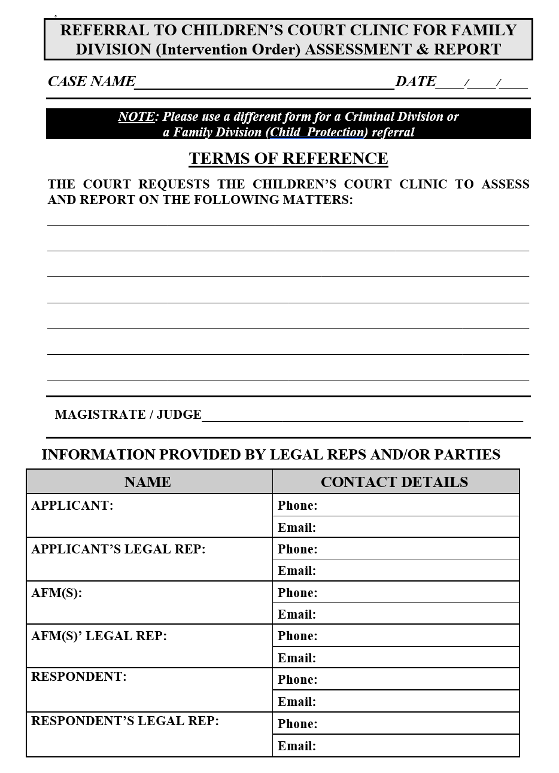

12.2.4 Terms of reference for Criminal Division assessments by the Children’s Court Clinic
The following template has been used since 2019 to provide minutes of proposed terms of reference for a Criminal Division assessment and report by the Children’s Court Clinic. An electronic version of this form can be downloaded from the CCV website. These terms of reference may also authorise the Clinic, at the direction of the presiding judicial officer, to make enquiries of other agencies or professionals involved with the child.

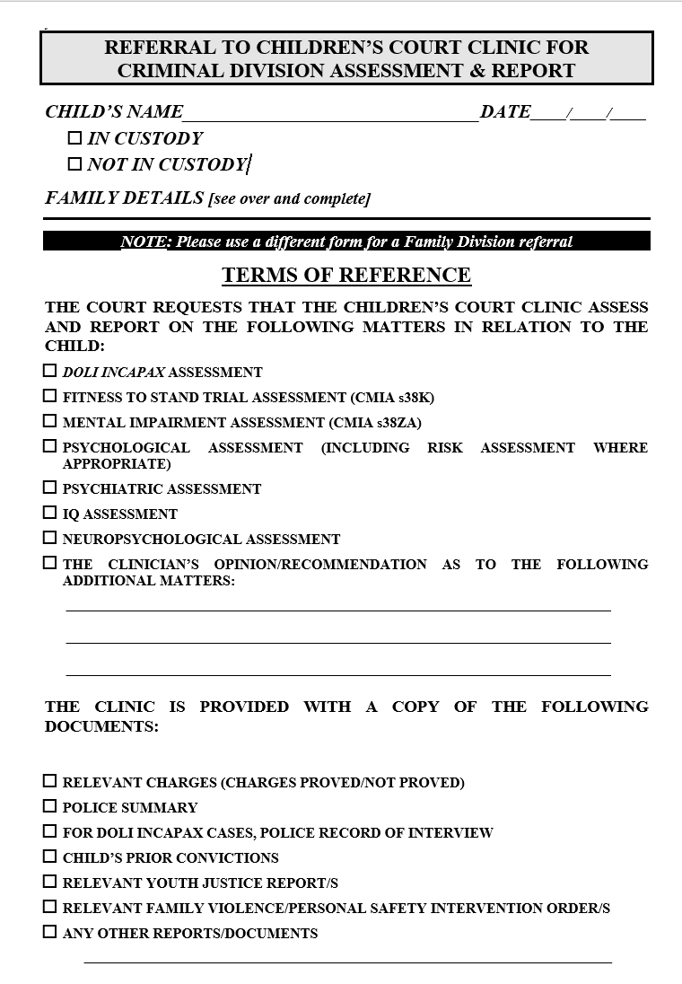
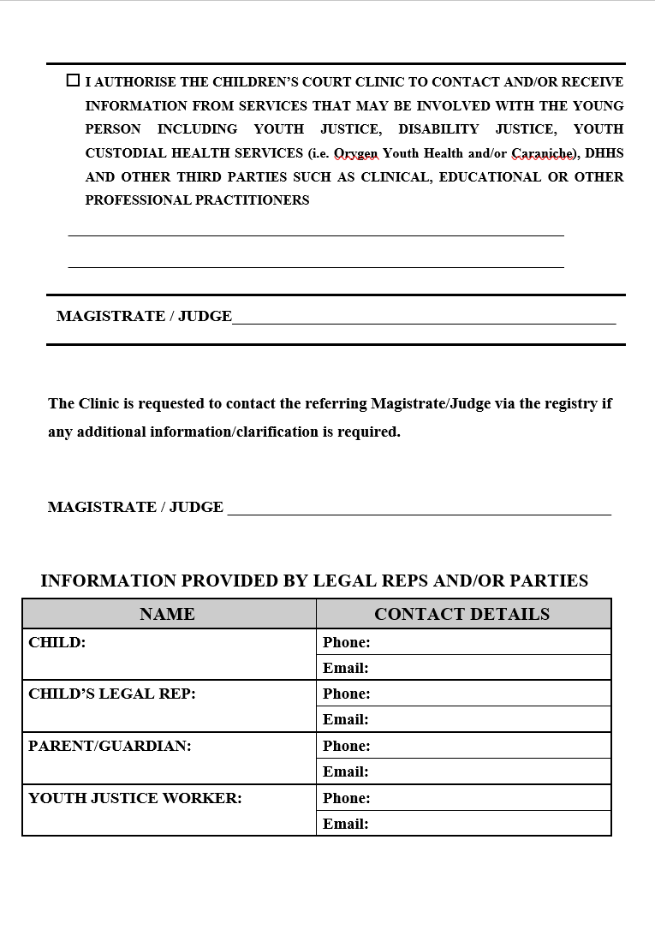

12.3 Operation of the Clinic

12.3.1 Ethos
The ethos of the Clinic is one of professionalism and respect for the persons assessed. The good of the child is the central focus of assessments, but the Clinic is family-centred and a systems approach, as well as a developmental perspective, is taken.

12.3.2 Qualifications & experience of clinicians
The Clinic is currently staffed by a number of highly skilled and competent clinicians, assisted by a small administration team.

Many clinicians who work within the Clinic also hold academic and research positions within tertiary institutions, and/or hold clinical positions either within the public mental health sector, or forensic treatment services. All clinicians hold post-graduate training at a Masters level or higher, and have demonstrated their expertise in clinical and/or forensic settings.

The Clinic also works through sessional clinicians engaged by the Director. This allows the Clinic to seek input from specialist clinicians – including all psychiatric assessments – where specific expertise is sought.

12.3.3 Clinical assessments
Clinic assessments involve a comprehensive information gathering process that allows for the specific Terms of Reference [TOR] to be addressed by the clinician, thereby enabling appropriate recommendations to be made to the Court. The TOR are the drivers of the assessment and should provide relevant context to guide the clinician’s focus. The more specific the TOR are the better. The majority of the requests for Clinic reports are for family assessments.
For a family assessment in a child protection case the TOR should specify who should be involved in the assessment and who should be considered as caregivers for the child. Such family assessments usually take a substantial amount of time and – depending on the TOR – generally involve:
- Interviews with each parent, partners (if applicable), each child of appropriate age (always in person) and carers. Interpreters are engaged whenever needed.
- Observations of the children with each parent (subsequently with partner added) and with carer.
- Psychometric assessments (Adults: Personality Ax, Mood Ax, Trauma Ax – Children: Mood Ax, Behavioural Ax, Trauma Ax) on the day if possible.
- Discussion with external services/supports (such as psychologists/psychiatrists, school staff, residential carers, NDIS coordinators, GPs, child protection workers and support services) for each family member.
Depending on the TOR, a family assessment will usually contain:
- a risk assessment (in relation to violence, family violence, sexual violence and neglect/child maltreatment); and
- an assessment of protective capacity.
These assessments are all intended to inform risk management strategies. It is important to note that all risk assessments are only as good as the information on which they are based. Hence the importance of accurate historical information about the family.

The Clinic’s current assessment protocols do not provide for a formal assessment of attachment. Clinicians do assess for parental attunement/sensitivity to the child/children and the ability for mentalisation (understanding the child as a unique individual with their own thoughts, feelings, wishes and experiences) – both of which contribute to attachment – and can comment on the nature and quality of the parent-child relationship and on behaviours that are indicative of attachment.

In relation to mental health of family members the Clinic’s focus is on recognising problematic behaviours and how these impact on parenting, as well as what supports are necessary. If further highly specific assessment is needed, for example, neurological assessment, assessment for learning disorders, or where treatment for a mental health/psychological issue is indicated, this will be recommended for consideration by the Court within the report provided. Whilst the Clinic does not initiate or facilitate any such recommendations, where possible it tries to provide specific referral options. As such, any follow-up of the Clinic’s recommendations is the responsibility of the Court (generally by way of conditions on orders), DFFH or the family.

Prior to the COVID-19 pandemic, all referrals to the Children’s Court Clinic were assessed within the Clinic building located within the Children’s Court premises in Melbourne. However, where a young person is in custody, or residing in Secure Welfare, clinicians are able to travel to these facilities to undertake their assessment. From March 2020 onwards, the pandemic had a large impact on Clinic assessments. There was a significant reduction in Criminal Division referrals commensurate with a significant drop in charges filed in the Children’s Court during the various ‘lockdown’ periods. In addition, Stage 4 restrictions, which came into effect in late July 2020, resulted in the Clinic solely conducting Telehealth assessments for the period during which face-to-face assessments were not permitted. As such, many reports provided to the Court during this period were somewhat modified in the issues that could be addressed.

Currently, assessments are undertaken using a combination of Telehealth and in-person assessment processes, which allows for the risks to staff and families to be minimised, whilst also allowing for the necessary interviews and observations considered necessary to the assessment process to proceed. This process accords with paragraph 21 of the President’s Practice Direction No.1 of 2024:
“Upon the Children’s Court requesting the Children's Court Clinic to provide a report, assessments will be conducted either in person, remotely by Telehealth or by other non-contact means as are required to facilitate the preparation and provision of the report.”

A clinician submitting a report is available for cross-examination at city, metropolitan or country courts when subpoenaed by a party or required to attend by notice given under s.550 of the CYFA by the child, a parent, the Secretary of the Department of Families, Fairness & Housing or the Court. Though the clinician will sometimes attend country courts in person, more often his or her evidence will be by video-conferencing link. In 2013/2014 a notice under s.550 was given to a clinician in 122 cases and in 4 cases a sub-poena was served on a clinician. Cross-examination of the clinician eventuated in 34 of these 126 cases (27% of requests for attendance).

Subject only to the question of relevance to the specific referral received, it is a decision for the individual clinician which persons should be involved in the clinical assessment in any particular instance. The case of NM, DOHS v BS [Children's Court of Victoria, unreported, 21/12/2004] involved applications to extend and to revoke a guardianship to Secretary order in circumstances where the 4 year old child BS was living with long-term carers subject to a permanent care caseplan. A Children's Court Clinic report had been prepared in which the clinician had performed an assessment of the carers which was not favourable to the DOHS' case. Counsel for DOHS strenuously submitted that this report was inadmissible, the court having no jurisdiction to receive it. In ruling that the assessment of the carers performed by the Clinic was both relevant and admissible, Judge Coate held that where the court has ordered a clinic report and the child's current placement is in issue, it is the decision for the particular clinician as to whether or not those carers should form part of the clinical assessment. At p.17 Her Honour said:
"In this case, a professional assessment has been undertaken and is available to assist the court in assessing the actual and potential benefit to the child of that placement. It is crucial, particularly in circumstances where DOHS have made it clear that they do not intend to call [the carers] to give evidence, that all available evidence with respect to them be before the court in these proceedings to allow the court to fulfil its statutory function."

THE REST OF THIS PAGE IS BLANK

12.3.4 Statistics
NUMBERS OF CHILDREN REFERRED TO THE CLINIC FOR ASSESSMENT
YEAR | CRIMINAL  DIVISION | CHILD  PROTECTION | FAMILY  VIOLENCE | TOTAL | METRO- POLITAN | COUNTRY
1998/1999 | 161 (28%) | 458 (74%) |  | 619
1999/2000 | 165 (26%) | 459 (74%) |  | 624
2000/2001 | 176 (28%) | 444 (72%) |  | 620
2001/2002 | 223 (34%) | 427 (66%) |  | 650
2002/2003 | 265 (35%) | 497 (65%) |  | 762
2003/2004 | 222 (25%) | 666 (75%) |  | 888
2004/2005 | 229 (25%) | 686 (74%) | 10 (1%) | 925
2005/2006 | 224 (25%) | 640 (71%) | 29 (3%) | 893
2006/2007 | 303 (30%) | 682 (67%) | 34 (3%) | 1022* | 660 | 362
 | There were 3 “other” referrals in 2006/2007: an assessment of the ability of a 5 year old child to give evidence in a case and 2 special referrals of youths from the Melbourne Magistrates’ Court.
2007/2008 | 346 (32%) | 697 (65%) | 29 (3%) | 1072 | 717 | 355
2008/2009 | 313 (29%) | 712 (65%) | 60 (6%) | 1085 | 686 | 399
2009/2010 | 337 (31%) | 725 (66%) | 28 (3%) | 1090 | 683 | 407
2010/2011 | 299 (31%) | 613 (65%) | 39 (4%) | 951 | 608 | 343
2011/2012 | 258 (30%) | 583 (67%) | 31 (3%) | 872 | 540 | 332
2012/2013 | 262 (34%) | 487 (64%) | 18 (2%) | 767 | 475 | 292
2013/2014 | 232 (30%) | 518 (68%) | 16 (2%) | 766 | 493 | 273
2014/2015 | 293 (30%) | 671 (68%) | 23 (2%) | 987 | 601 | 386
2015/2016 | 280 (28%) | 641 (70%) | 19 (2%) | 992 | 627 | 365
2016/2017 | 229 (27%) | 629 (72%) | 6 (1%) | 864 | 490 | 374
2017/2018 | 259 (30%) | 582 (68%) | 14 (2%) | 855 | 522 | 333
2018/2019 | 202 (22%) | 703 (77%) | 9 (1%) | 914 | 507 | 407
2019/2020 | 140 (30%) | 332 (70%) | 2 (0.3%) | 474
2020/2021 | 36 (11%) | 281 (89%) | 4 (0.1%) | 321
 | The significant reduction in the numbers of referrals in 2019/2020 & 2020/2021 is primarily a consequence of the COVID-19 pandemic and its impact on the number of cases initiated in and the throughput of the Children’s Court.

On average approximately 65% to 80% of the referrals to the Clinic involve child protection cases in the Family Division of the Children’s Court. The child protection referrals predominate in the work of the Clinic, these matters usually being more complex and time consuming than the bulk of the referrals from the Criminal Division.

The referrals shown in the above table relate to individual children. In child protection referrals it is usual for a single report to be prepared for a family whether that family has one child or multiple children (including half-siblings and step-siblings). It follows that the number of reports prepared by the Clinic in child protection referrals is significantly less than the number of children referred. For instance, in 2018/2019 a total of 712 children were referred in Family Division cases (all but 9 being from child protection cases) while the Clinic prepared 313 reports.

CLINIC REPORTS PREPARED ACROSS BOTH DIVISIONS
YEAR | TOTAL NUMBER | DESCRIPTION
2018/2019 | 492 | Family Division 313 reports  Psychology 245  Psychiatry 12  Neuro 56 | Criminal Division 179 reports  Psychology 131  Psychiatry 19  Neuro 29
2019/2020 | 384 | For the Family Division 198 family assessment reports, 39 neuropsychological reports and 12 psychiatric reports were prepared. For the Criminal Division 97 psychological assessment reports, 27 neuropsychological reports and 11 psychiatric reports were prepared.
2020/2021 | 182 | For the Family Division 113 reports were prepared. For the Criminal Division 36 reports were prepared. A further 33 reports were neuropsychological assessments undertaken across both divisions.
2021/2022 | 198 | For the Family Division 134 family assessment reports were prepared for child protection cases. For the Criminal Division 38 psychological or psychiatric reports were prepared. A further 26 reports were neuropsychological assessments undertaken across both divisions.
2022/2023 | 238 | Family Division 195 reports  Psychology 138  Psychiatry 10  Neuro 47 | Criminal Division 43 reports  Psychology 21  Psychiatry 6  Neuro 16

The marked drop in the number of reports prepared since 2018/2019 is likely to be partly related to the COVID-19 pandemic. In addition, the writer suspects that the inquisitorial role of judicial officers applying the principles in s.215B of the CYFA in Family Division readiness hearings may have led to a greater and earlier resolution of child protection cases without the need for as many contested hearings as in the past. Readiness hearings were introduced towards the start of the pandemic and are discussed in detail (including resolution statistics) in section 4.9.4. The fundamental precondition for the ordering of a Clinic assessment and report in the Family Division is in s.560(b) of the CYFA and requires the Court to be satisfied that such a report is necessary to enable it to determine the proceeding. It follows that an increase in the rate of cases resolved prior to a contested evidence-based hearing is likely to lead to a reduction in the rate of cases requiring a Clinic report to enable the Court to determine the proceeding.

The very large drop in the number of reports ordered in the Criminal Division since 2019/2020 mirrors the very large drop in the number of sentencing orders made by the Criminal Division and the continuing rise in the number of diversion orders made in cases which will virtually never require an assessment and report by the Clinic. The statistics (which are detailed in sections 11.7.1 & 10.7K respectively) are summarized in the table below. The writer also suspects that the judgment of the High Court in RP v The Queen [2016] HCA 53; (2016) 259 CLR 641, emphasising that the onus of rebutting the presumption of doli incapax rests squarely on the prosecution, may be a small contributing factor in the reduction in reports sought from the Clinic in Criminal Division cases.

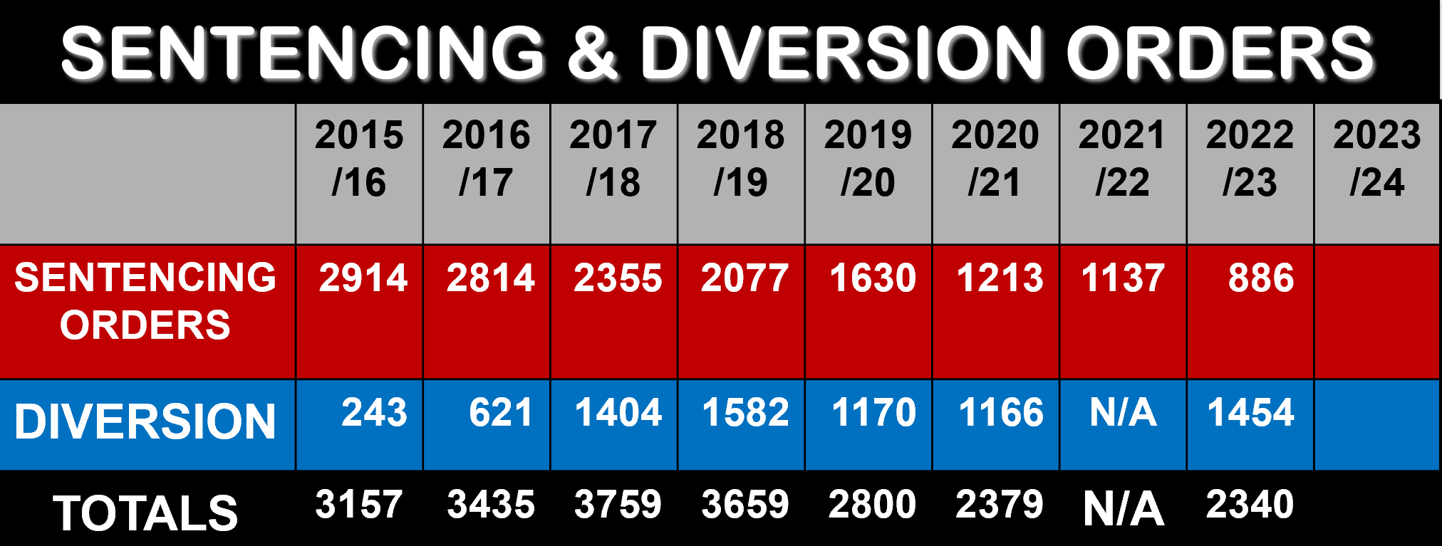

12.3.5 Research role
Since 2019 a research partnership has been in effect between Court Services Victoria and Swinburne University of Technology in which post-doctoral research fellows are engaged on a 1.0 EFT basis at the Children’s Court Clinic on various research projects.

12.4 Children's Court Clinic reports

12.4.1 The competing principles
Under s.546(2)(b) of the CYFA one of the functions of the Clinic is “to submit reports to Courts and other bodies”. Whenever the Clinic provides a report to the Court two competing principles come into play. The principles of “natural justice” and “procedural fairness” require that all parties to the litigation have a right to a full and fair hearing, a right which ordinarily requires the Court to ensure that all parties are aware of – and are given a proper opportunity to respond to – all evidence to which the Court is privy. On the other hand, there is the principle of “clinician-client confidentiality”, the ethical imperative of the clinician who conducted the assessment to preserve the confidentiality of the information obtained from his or her client in the course of the professional assessment, an imperative necessarily tempered by the fact that the assessment is conducted in the knowledge that the clinician is required to prepare a report for the Court. While the Court understands that a clinician would wish to preserve as much of this confidentiality as possible, the principles of “natural justice” and “procedural fairness” would rarely be satisfied if the Court kept the information in a Clinic report away from some or all of the parties.

12.4.2 Distribution of and access to Family Division reports
If the Family Division of the Court orders a report from the Children’s Court Clinic, s.562(1) of the CYFA requires the Clinic not less than 3 working days before the hearing to forward the report to the proper venue of the Court.

Section 562(2) permits the Clinic, if it is of the opinion that information contained in a Clinic report will be or may be prejudicial to the physical or mental health of a child or a parent of the child, to forward a statement to that effect to the Court with the report.

Section 562(3) of the CYFA tips the balance between “natural justice” and “clinician-client confidentiality” on to the side of “natural justice’ in requiring the Court – subject to s.562(4) – to release a copy of the report to each of the following–
(a) the child;
(b) the parent(s);
(c) the Secretary DFFH;
(d) the legal practitioners representing the child;
(e) the legal practitioners representing the parent(s);
(f) the legal representative of the Secretary or an employee authorised by the Secretary to appear in proceedings before the Family Division;
(g) a party to the proceeding; and
(h) any other person specified by the Court.

The only circumstances in which the Court may refuse to make a full release to each of the above persons are set out in s.562(4). After having regard to the views of the parties and any statement from the Clinic under s.562(2), the Court may–
(a) if satisfied that the release of the report or a particular part to the Secretary may cause significant psychological harm to the child–
- release the report to the Secretary nonetheless;
- refuse to release the report or part report to the Secretary; or
- determine a later time for the release or part thereof to the Secretary;
(b) if satisfied that the release of the report or a particular part to any other person will be prejudicial to the development or mental health of the child, the physical or mental health of the parent or the physical or mental health of that person or any other party–
- release the report to the person nonetheless;
- refuse to release the report or part report to the person; or
- determine a later time for the release or part thereof to the person.

Section 562(5) of the CYFA empowers the Court to impose conditions in respect of the release of a Children’s Court Clinic report. However, it is the writer’s view that s.562(5) does not impose an unfettered power on the Court which would enable it to impose conditions which are contrary to the general release provisions in s.562(3), read in conjunction with s.562(4).

12.4.3 Distribution of and access to Criminal Division reports
Distribution of and access to any report ordered in the Criminal Division other than a pre-sentence report does not appear to be the subject of any legislative provisions.

If the Criminal Division of the Court orders a pre-sentence report from the Children’s Court Clinic, s.574 of the CYFA requires the Clinic to file the report in the Court at least 3 working days before the return date.

Section 575(1) requires the clinician, within the period referred to in s.574, also to send a copy of a pre-sentence report to–
(a) the child;
(b) the legal practitioners representing the child; and
(c) any other person whom the Court has ordered is to receive a copy.
However, under ss.575(2) & 575(3) the clinician is not required to send copies of the report to (a) the child or (c) any other person whom the Court has ordered is to receive a copy if–
- the clinician is of the opinion that information contained in the report may be prejudicial to the physical or mental health of the child; or
- the child notifies the clinician that he or she objects to the forwarding of copies of the report.

In practice, the Court has long performed the function of distribution of all Criminal Division Clinic reports on behalf of the Clinic.

12.4.4 Confidentiality of Children’s Court Clinic reports
Section 552 of the CYFA provides that subject to any contrary direction by the Court, a person who prepares or receives or otherwise is given access to any Clinic report, or part report, must not, without the consent of the child or parent, disclose any information contained in that report, or part report, to any person not entitled to receive or have access to the report or part. The prohibition in s.552(1) of the CYFA also applies to a copy of such report. Breach of this confidentiality provision is subject to a penalty of 10 penalty units [$1923].

The above confidentiality provisions do not prevent–
- the Secretary DFFH or his or her employee or legal representative; or
- an honorary youth justice officer or an honorary parole officer to the extent necessary to exercise his or her powers or perform his or her duties-
from being given or having access to a report to which Part 7.8 of the CYFA applies.

If because of s.575(2) part or all of a pre-sentence report was not sent to the child, s.575(5) prohibits a person who receives a copy – unless otherwise directed by the Court – from disclosing to the child any information contained in the report or part that was not sent to the child. Breach of this confidentiality provision is also subject to a penalty of 10 penalty units.

